Shabbos Stories For
Parshas Lech lecha 5787
Volume 18, Issue 6 13 Cheshvan/October 24, 2026
Printed L’illuy nishmas Nechama bas R’ Noach, a”h
True Hesed
By Avrohom Barash

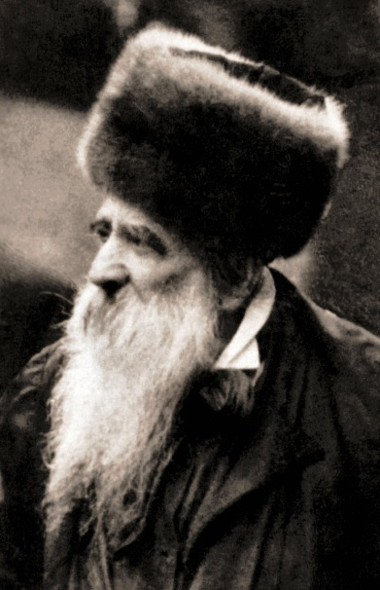

R’ Yissachar Dov Rokeach of Belz would distribute sedakah to poor families before the yamim tobim to enable them to purchase what they needed for the holiday. Then, on ereb yom tob, he would send money to these needy people again. His son, R’ Mordechai, the Rav of Bilgoray, did not understand the purpose of the second donation, especially since its arrival at such a late hour did not allow the recipients to make use of it for holiday needs.
The Belzer Rav explained, “The money I sent these families earlier has enabled them to purchase food for yom tob so that they will enjoy the holiday. But how can a poor man be happy when he knows that immediately after yom tob he will be in the same dire straits again? He will once more find himself destitute, wondering where he will get the funds for his next meal. By sending this second sum, I ensure that these unfortunate individuals will be able to enjoy the holiday without worry about how they will manage as soon as the holiday ends. (Excerpted from the book “A Mazeldig Voch”)
Reprinted from the Parshas Bereishis email of The Weekly Vort.
The Baby Carriage

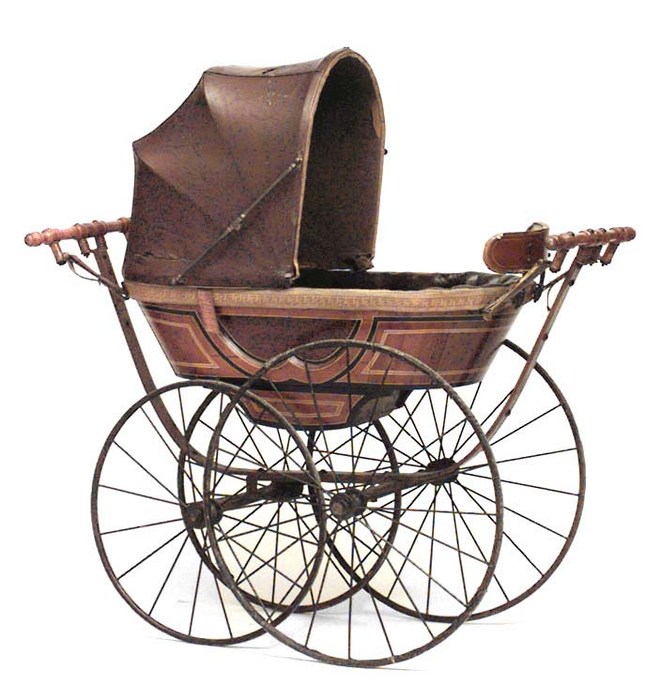

The story is told of two chassidim who would annually travel to visit their Rebbe for Succos. On the way, they would stop at a certain inn run by an observant Jewish couple. One year, the innkeeper approached them humbly and asked, “You know that I am not a chasid, but nevertheless I have a favor to ask of you: My wife and I have been married for ten years and have not been blessed with a child. Can you ask the Rebbe to intercede on our behalf?”
The chassidim agreed to speak to the Rebbe, and, the next morning, the innkeeper’s wife began parading around town with an expensive baby carriage, heralding the future birth of their child. When her friends gathered to wish her mazal tov, she explained that, while she was not yet with child, she soon would be. After all, the chassidim were going to speak to their Rebbe.
Seeing this, the two chassidim were slightly embarrassed because they knew that prayers do not always engender the results for which they hope. Hashem decides what is best, and it does not always precisely correspond with our aspirations.
The following year, the chassidim returned to the inn, as the innkeeper’s son’s circumcision was in progress. The joy was palpable, as everybody shared in the celebration – everybody but one of the chassidim. He said nothing until he arrived at the Rebbe’s home, and he began to pour out his heart to him:
“For thirty years, I have been your trusted disciple. Every year, I ask for your blessing that my wife and I be blessed with a child. We have yet to be blessed. Yet, Hashem answered the innkeeper, who is not a chasid, on his first request. Why?”
The Rebbe took his disciple’s hands in his and looked deeply into his tear-stained eyes and asked, “Tell me something: during these thirty years, did you ever buy a baby carriage? How great was your faith compared to that of the innkeeper’s wife?”
This story tells it all. We must take our emunah to the next level. We must demonstrate our belief by participating actively in our faith. Perhaps we should not go as far as buying a baby carriage, but we must realize that emunah is not a spectator event.

Reprinted from the Parshas Bereishis 5786 email of Rabbi L. Scheinbaum’s Peninim on the Torah, a publication of the Hebrew Academy of Cleveland.

The Cherries of the
Dark Winter Night
By Yehuda Z. Klitnick

In a bitter, icy Chanukka night, several young Yeshiva boys gathered together, and sat down at a wooden table and began to play cards (karton). The boys enveloped in warmth, were entirely consumed by the game. It was midnight when a sudden, sharp knock echoed at the door.
The young men wondered: Who could possibly be wandering outside in such a freezing night? One of them rose, and opened the door. Standing there was an old Gentile stranger, his clothing dusted in white, holding in his hands a basket filled with ripe, red cherries (krashin)
The old stranger looked at them with a strange glance and asked if they wished to buy his delicious cherries. The young men replied, "Ah, we would love to buy these beautiful cherries from you! But we do not have a single coin left in our pockets. Every coin is tied up in our card game, and from that pot, not a single cent can be withdrawn."
The old man smiled and answered, "Do not let that trouble you at all! I will willingly give you all these cherries right now, and as for the money I will return tomorrow night at this exact same hour to collect my payment."
The men agreed, thanking the old man for his generous heart. With a nod, the stranger turned back into the darkness and disappeared into the raging snowstorm. The young men carried the basket over, set it upon the playing table, and immediately returned to their game. As the hours flew by, they played, continuously reaching into the basket, eating the sweet cherries, and spitting the pits onto the wooden floor.
So, it continued until exhausted, they finally threw themselves onto their beds. A heavy sleep overtook them, that they overslept the entire morning, missing saying
Shema and Shacharis. When they finally awoke late in the afternoon, they stepped out into the outer room where they had spent the night playing cards. There, scattered
across the floor, lay hundreds of cherry pits. Suddenly,
one of the young men spoke aloud:

"My brothers, a great wonder has occurred here. Who was that old Gentile who brought us fresh cherries in the middle of a winter blizzard? Where did he come from, and who sent him to our door in such freezing, terrible weather? But even more terrifying than that—where in the world did he find sweet, ripe cherries in the middle of the winter? Fresh fruit like this does not exist anywhere in our region during the winter months! And why would a total stranger trust us as if we were his lifelong friends? This is no ordinary occurrence!”
The realization dawned upon them: A heavy fear fell over them as they remembered that in a few hours, the old man would return to demand his debt. Who knew what terrible retribution or dark power he might exact upon them? Unanimously, they resolved that their only hope was to run straight to the Holy Rabbi of Kaliv. They would relate their foolishness, confess their sin, and recount the supernatural event, praying that the Rebbe extract Heaven's mercy to save them from the claws of the lurking enemy.
When they stood before him and related everything that had transpired, the Rebbe’s face burned like a fiery torch. He began to cry out at them in righteous rebuke, his voice like thunderous flames of fire:
"Woe unto you!" the Rebbe cried. "Know that this old Gentile was no human being! He was a manifestation of the Kelipah (Satan)! Through your deep immersion in that impure, unholy game, you aroused these dark forces! And when you accepted his fruit and ate from his basket, you walked directly into his net! You are now trapped in his evil web, and mortal danger hangs over your very souls!"
Heartbroken and shaken, they wept, regretting their foolish actions with all their hearts. They fell at the Rebbe's feet, weeping and pleading: "Rebbe, have mercy
upon our souls! Carve out for us a pathway of Teshuvah!"
Seeing their genuine heartbreak, the Rebbe softened. He asked, "Do you accept upon yourselves, with a complete commitment and a whole heart, that from this day never touch those cards again?"
With tear-filled eyes, the young men swore with a complete and resolute heart that they would never return to such emptiness. The Rebbe instructed them: "Return to me exactly half an hour before the appointed midnight hour when the old man is
scheduled to return. We shall see what Heaven will enable me to do."
When the designated hour arrived, they entered the Rebbe's holy chamber. The Tzaddik untied his gartel and handed it to them. "Hold tightly onto my gartel," the Rebbe commanded. "Every single one of you, grab hold, and do not let go until I tell you to loosen your grip!"
The young men reached out, trembling, and held fast to the gartel of their Rebbe. Minutes passed in intense, terrifying silence. After some time had elapsed, the Rebbe turned to them with a smile and said, "It is done. You may let go of my gartel. Go in peace, and fear no more.

Reprinted from the Parshas Bereishis 5787 email of Pardes Yehuda.

Draw Them Closer
By Rabbi Moshe Hirschberg

Rav Avraham Altman, Rosh Yeshiva of Yeshivas Ateres Tzvi, would travel each year to Argentina, where he grew up after his family fled Europe when he was a child. In the winter of 2016, he traveled there with his son, Rav Eliyahu Meir, on behalf of the yeshiva. During their stay, father and son visited different shuls, delivering derashos and words of chizuk to strengthen the local Jewish community.
One Shabbos, after Rav Eliyahu Meir spoke in a local shul, a man approached him and warmly thanked him for his derashah. As they spoke, Rav Eliyahu Meir learned that the man owned a large pants-manufacturing factory. He suggested that he and his father visit the factory, and the owner readily agreed.
When they arrived on Monday, the owner listened with interest as they spoke about the yeshiva and wrote them a generous check. Then, with a troubled expression, he confided in them about his business partner. The man was Jewish but very far removed from Torah and mitzvos, and he was considering marrying a non-Jewish woman, Rachmana litzlan. The owner had tried repeatedly to dissuade him, but nothing had helped.

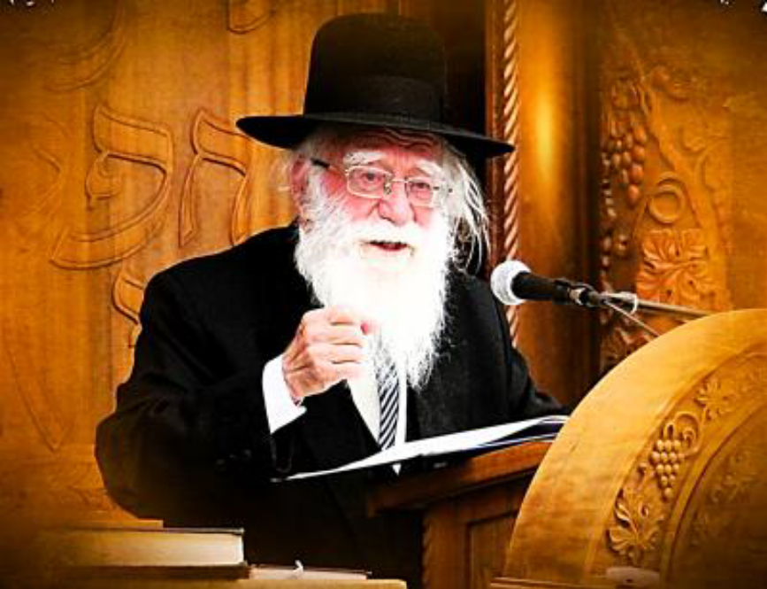
Rabbi Avraham Altman

Rav Altman asked him to call his partner into the room. Though uncomfortable at having revealed something so personal, the owner complied. When the partner entered, Rav Altman greeted him warmly and shook his hand. “Your partner just gave us a generous donation for the yeshiva,” he said. “But since you are partners, you have a share in it as well, so I owe you a thank-you, too!”
Rav Altman told him briefly about the yeshiva and the zechus of supporting Torah. Then, still holding his hand, he looked directly into the man’s eyes. “You know something?” he said warmly. “You really impress me. I can see that you are a very special person.”
The unexpected words touched the man deeply, bringing tears to his eyes.
Rav Altman invited both partners to dinner the following evening. As they sat together, Rav Altman continued treating the man with genuine warmth and respect. At one point he casually asked, “Tell me, are you married?”
“No,” the man replied.
“Then I give you a berachah that this year you should get married,” Rav Altman said. “And I’m coming to dance at your wedding. Don’t forget to invite me. I’ll make every effort to come from Eretz Yisrael especially to dance with you.”
Rav Altman later recalled that he could see the turmoil on the man’s face. The man had no idea that the Rav knew of his plans, but one thought must have been racing through his mind: The Rav is going to come from Eretz Yisrael to dance at my wedding, while a priest is officiating?
Several months later, in Av, Rav Altman received an emotional phone call from the factory owner. His partner had completely abandoned his plans and was now engaged to a Jewish woman who was stronger in Yiddishkeit than he was. The wedding would take place that winter, precisely when Rav Altman was scheduled to return to Argentina. And Rav Altman kept his promise: He attended the wedding and danced with the man at his kosher Jewish wedding.
Rav Altman had never rebuked the man or told him what was wrong with him. Instead, he showed him what was right with him. He treated him with warmth, dignity, and genuine affection, allowing the man to see himself differently.

Reprinted from the Parsha Bereishis 5787 email of Zichru Toras Moshe.

The Casual But Powerful Joke

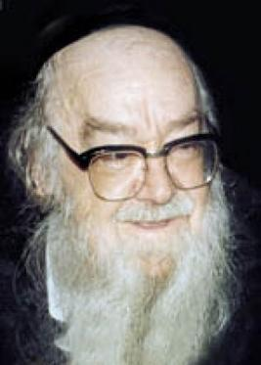
Rabbi Sholom Schwadron

There is an amazing story about how a single family embraced Yiddishkeit because of a comment made years earlier. The tale begins when one Yerushalmi Maggid, R’ Reuven Karlenstein zt”l, posed a deeply penetrating question to another famous Maggid of Jerusalem, R’ Shalom Shwadron zt”l:
“R’ Shalom, tell me: how does one put a neshama into a person?”
R’ Shalom chuckled before offering a striking mashal to explain. “At the end of Parshas Bereishis, the Torah tells us how Kayin sought to kill his brother Hevel. Understandably, Kayin did not know how to kill, as no human had ever been killed. In his confusion, Kayin began hitting Hevel, beating him mercilessly and severing his limbs. Yet despite excruciating agony, Hevel remained alive.
“Seeing Hevel’s suffering, Hakadosh Boruch Hu summoned a bird, which attacked another bird and pecked relentlessly at its companion’s neck until it died. Watching this, Kayin struck Hevel across the neck, and Hevel breathed his last.
“Since that day,” R’ Shalom explained, “humanity has known precisely how to take a neshama, a soul out. But putting a soul back in? That remains a mystery. A person can never anticipate the effect their words might have on another human spirit. Sometimes, a single offhand remark or lighthearted joke can unleash incredible transformation.”
To illustrate, R’ Shalom shared a personal experience with R’ Reuven. He told him how many years earlier he had traveled to his daughter in Kiryat Gat for Shabbos. Mid-meal on Friday night, a knock sounded at the door. Standing outside was a local Rav asking if R’ Shalom could possibly grace the community with a shiur after the seudah. What an honor it would be, he told the Maggid. Well, he wasn’t exactly prepared and so R’ Shalom hesitated. But he felt could not refuse. Immediately, after the seudah and with a prayer on his lips, R’ Shalom headed to the Beis Medrash.
The shul was packed as word had spread fast. Stepping up to speak, R’ Shalom kept it simple. With so much experience under his belt, he had no trouble weaving together thoughts on the weekly parsha, a few parables, and engaging stories. In the middle of his lecture, R’ Shalom decided to bring the crowd into it.
“Tell me, Rabbosai, why is it that in recent years people have begun holding elaborate ‘Bas Mitzvah’ celebrations for young girls, something our ancestors never practiced? Traditionally, only thirteen-year-old boys celebrated reaching the age of mitzvos. Why has this custom spread to girls nowadays?”
The audience remained silent. Smiles rippled through the room as R’ Shalom delivered his punchline: “Once upon a time, when a Jewish boy reached thirteen, he began to wear tefillin and dedicate himself to Torah study. This naturally did not apply to a young girl, which is why only boys had a ceremony.
“But today, girls look around and see that even boys reaching thirteen aren’t makpid (careful) to put on tefillin or study Torah - yet everyone throws them a grand party! So, the girls say, ‘If the boys get a celebration without doing anything, why shouldn’t we? Why are we any different?’”
The congregation laughed, and the evening ended. To R’ Shalom, it was merely an amusing anecdote to keep the audience engaged. Years later, a gentleman approached R’ Shalom in Jerusalem.
“The Rav likely does not remember me,” the man said, “but I was in the synagogue that Friday night in Kiryat Gat when you shared that joke about Bas Mitzvah parties. Your words struck me like a lightning bolt. I asked myself: Is it really true that my sons have turned thirteen and reached the age of responsibility, yet they do nothing differently than my daughters? Are they truly living without tefillin?”
The thought haunted him all weekend. “First thing Sunday morning, I asked my sons to begin putting on tefillin every day. After all, they had a Bar Mitzvah and received a pair of tefillin. Soon, that small step led us to enroll them in religious schools. That spark spread through our home, inspiring all of us to return to teshuvah. Today, our entire family is fully observant.”
Finishing his account, R’ Shalom turned back to R’ Reuven and concluded, “You see, we know how to take a neshama out, but putting a neshama back in is something far greater than our plans. Who could have believed that a casual joke, spoken spontaneously during an unplanned drasha, would inspire an entire family to rebuild their spiritual lives forever?”

Reprinted from the Parshas Bereishis 5787 email of Rabbi Dovid Hoffman’s Torah Tavlin.
The Wondrous Gift
By Rabbi David Ashear



The pasuk says in Tehillim perek 19 "השמים מספרים כבוד קל ומעשי ידיו מגיד הרקיע – David HaMelech is telling us that he looked at the creations in the world in amazement, seeing the greatness of Hashem in them.
Studies have shown that the entire earth in which we live upon is 1.3 million times smaller than the Sun and there are stars in outer space that are big enough to contain 9.3 billion suns inside of them. The vastness is mind boggling.
Astronomers estimate that there are two trillion galaxies just in the observable universe and all of the stars, planets and galaxies that we can see make up just 4% of the entire Universe. Which means there's another 96% which we can't see, detect or even comprehend.
One of the reasons Hashem made the world like this is for us to realize His greatness. Somebody could become a believer in Hashem just by observing His creations.

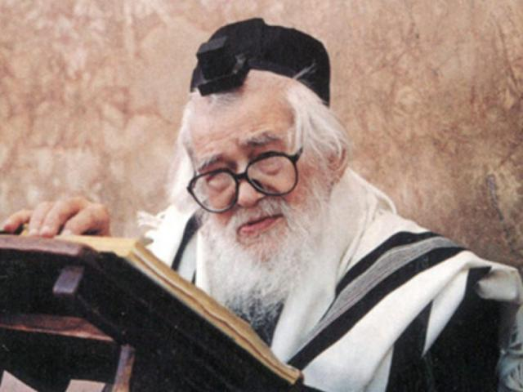
Rav Elazar Shach

Rav Elazar Shach once went to visit someone in the hospital. At that time, the Rabbi himself was in his 90's and the hospital staff accorded him great honor. One of the top doctors there escorted the Rabbi out of the hospital when he left and Rav Shach turned to him and asked what kind of car he drove. The doctor answered, "A Mercedes."
Rav Shach then asked when he bought the car, to which the doctor replied, six months before that. Rav Shach asked further, why he needed a new car and what was wrong with his previous one. The doctor said, "Rabbi, I did have a Mercedes before as well, but they are always updating and making the car better."
Rav Shach then said, "We see from here, even the best cars on the market always have more room to improve in."
"Yes," replied the doctor.
Rav Shach then said, "I know you're an expert cardiologist. What do you think about doing something to the heart to improve it? Can you think of something in the heart that needs improving upon and fix it? Maybe one of the chambers is too small or maybe one of the lobes is too far to the left?"
The doctor said, "No, the heart is perfect and doesn't need any improvements."
Rav Shach then said, "Please tell me, who can make something so perfect that never needs improving upon?"
The doctor replied, "Only G-d." And they both smiled.
The brain is perfect, the eyes are perfect, every body part is perfect because they are the makings of Hashem. After David HaMelech wrote seven pesukim in that mizmor about the world, he switched gears and started speaking about the Torah saying, "תורת ה' תמימה משיבת נפש", and he continued with more pesukim.
Rabbi Zamir Cohen explained as follows: From a person observing the world and the creations of Hashem, we can come to emunah, but we'll still be left with a lot of questions regarding how and why things came into being. For that, Hashem gave us the ultimate gift, the Torah which is תמימה– complete – and has the answers to all of those questions.
And that brings a person peace of mind – משיבת נפש. When a person has clarity, he feels at ease. For millennia, philosophers and laymen have been trying to figure out the purpose of the world. How did the world start? How did man start? Is there life after death? All of these questions and more have perplexed the minds of mankind for all of history.
But we have all of the answers right in front of us, children in kindergarten know how the world started and know how Adam was created. We know our purpose, we know there is Olam Haba. Having clarity gives us peace of mind. As we begin once again reading the Torah from Bereshit, let us appreciate this wondrous gift that Hashem has shared with us.

Reprinted from a recent email of Living Emunah.

The Small Hammer

Rav Mottel Slonimer, zt”l, writes (Maamar Mordechai p.342) that sometimes it seems impossible to overcome the Yetzer Hara and to change one’s ways, and indeed it is impossible without Hashem’s help. However, if we only try, then Hashem will help us.
He notes the following story: Two Tzaddikim once made a pact with each other that whichever of them passes away first would come to his friend in a dream and tell him what happened in his judgment in Shamayim.
A while later when one of the Tzaddikim was Niftar, as promised, he soon afterward came to his friend in a dream to reveal what had happened to him. He said, “When the court reviewed all my deeds, they saw that everything was perfect except for one Aveirah that I had, and that was the sin of taking a bribe.”
He explained, “Once, when I was serving as the head of the Bais Din, one of the people involved in the case I was judging placed money into my pocket without me knowing about it. I later found the money but I didn’t know that it was related to
the court case from earlier, and I used it assuming it was money that I had placed there and forgotten about.
“For this, I was told that I would need to go to Gehinom to be cleansed, but I told the court that I didn’t want to go there, so instead, they brought me to a very large building. They told me that instead of going to Gehinom, I would have to demolish this building, and they handed me a small hammer to use.


“They said, ‘Tear down this building with the hammer, and when you finish, you will go straight to Gan Eden.’ I was devastated. It seemed that I would be working on knocking down the building for many years, as it was a very large building and I only had a small hammer to work with.
“But then I thought to myself, ‘Didn’t I wear a Talis and Tefilin every day during my lifetime and learn Torah and keep all the Mitzvos, only because I chose to do Hashem’s will? Well, right now, it is Hashem’s will that I break a large building with this small hammer. If so, what is there to be upset about? This is the will of Hashem, and I will do it with joy— even if it will take me many years to accomplish!
“With a heart full of Simchah, I raised the hammer and hit the building with all my might, and to my great astonishment, the entire building collapsed! I was then swiftly brought to my place in Gan Eden.”
Rav Mottel Slonimer teaches that this reminds us that at times it can seem like it will take forever to change ourselves, but we only just need to put up a little fight with the Yetzer Hara. Things may only seem impossible, but they aren’t. It is very likely that one strong blow against the Yetzer Hara will topple him, and we can grow into the person we have set out to be!

Reprinted from the Parshas Bereishis 5786 email of Rabbi Yehuda Winzelberg’s Torah U’Tefilah.

The Painful Letter of Recommendation
By Yoni Schwartz

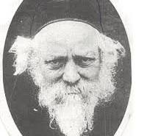
Rav Baruch Ber Leibowitz

Rav Baruch Ber had a daughter who struggled for a considerable amount of time to find the right Shidduch. Finally, she got engaged, and not just to any person, but to an outstanding bachur, one of Rav Baruch Ber’s talmidim. He was a genius and had amazing middos (traits). He was a very refined and mature person, and very caring. They both completely realized how amazing this Shidduch could be.
At some point after the engagement, however, the young man realized that this was not the right match for him, and he decided to break it off. Rav Baruch Ber’s daughter was absolutely heartbroken; she was crushed to her core. Rav Baruch Ber, as well, was absolutely broken to pieces.
This young man realized that things were just too awkward to continue as a talmid of Rav Baruch Ber’s in his yeshiva. He figured the right thing to do would be to switch to another yeshiva. However, back in those days, to switch yeshivas, a person needed a letter from the Rosh Yeshiva. So, he had to get a letter from Rav Baruch Ber - a positive recommendation about him - so he could get accepted into another yeshiva.
Writing such a letter was incredibly difficult for Rav Baruch Ber. He was deeply pained and was afraid that some of his negative emotions might come out in the writing. He genuinely struggled and had the courage and humility to honestly admit that. That is why he asked five different people to meticulously analyze the letter, to be certain that there was no hint of any negativity toward this bachur, and that his chances of getting accepted into another yeshiva would not be harmed even the slightest bit.
Reprinted from the Parshas Bereishis 5786 email of Torah Sweets.

